MLA0201-Fundamentals of Machine Learning

Name: Kaviya Kumara K (192425055)
Experiment 1:
Implement and demonstrate the FIND-S algorithm for finding the most specific hypothesis based on a given set of training data samples.

Code:
import pandas as pd
import matplotlib.pyplot as plt
data = pd.read_csv("car_data.csv")
attributes = data.columns[:-1]
hypothesis = ['0'] * len(attributes)
positive_class = 'High'
for index, row in data.iterrows():
if row['PriceCategory'] == positive_class:
for i in range(len(attributes)):
if hypothesis[i] == '0':
hypothesis[i] = row.iloc[i]
elif hypothesis[i] != row.iloc[i]:
hypothesis[i] = '?'
print("Learned Hypothesis:", hypothesis)
specific_count = sum(1 for h in hypothesis if h != '?')
total_attributes = len(hypothesis)
hypothesis_score = specific_count / total_attributes
p = 0.05
print("Hypothesis Score:", hypothesis_score)
print("Threshold p:", p)
if hypothesis_score <= p:
decision = "ACCEPTED"
else:
decision = "REJECTED"
print("Decision:", decision)
labels = ['Hypothesis Score', 'Threshold (p)']
values = [hypothesis_score, p]

plt.figure()
plt.bar(labels, values)
plt.title("Hypothesis Score vs Threshold")
plt.ylabel("Score Value")
plt.xlabel("Measure")
plt.show()

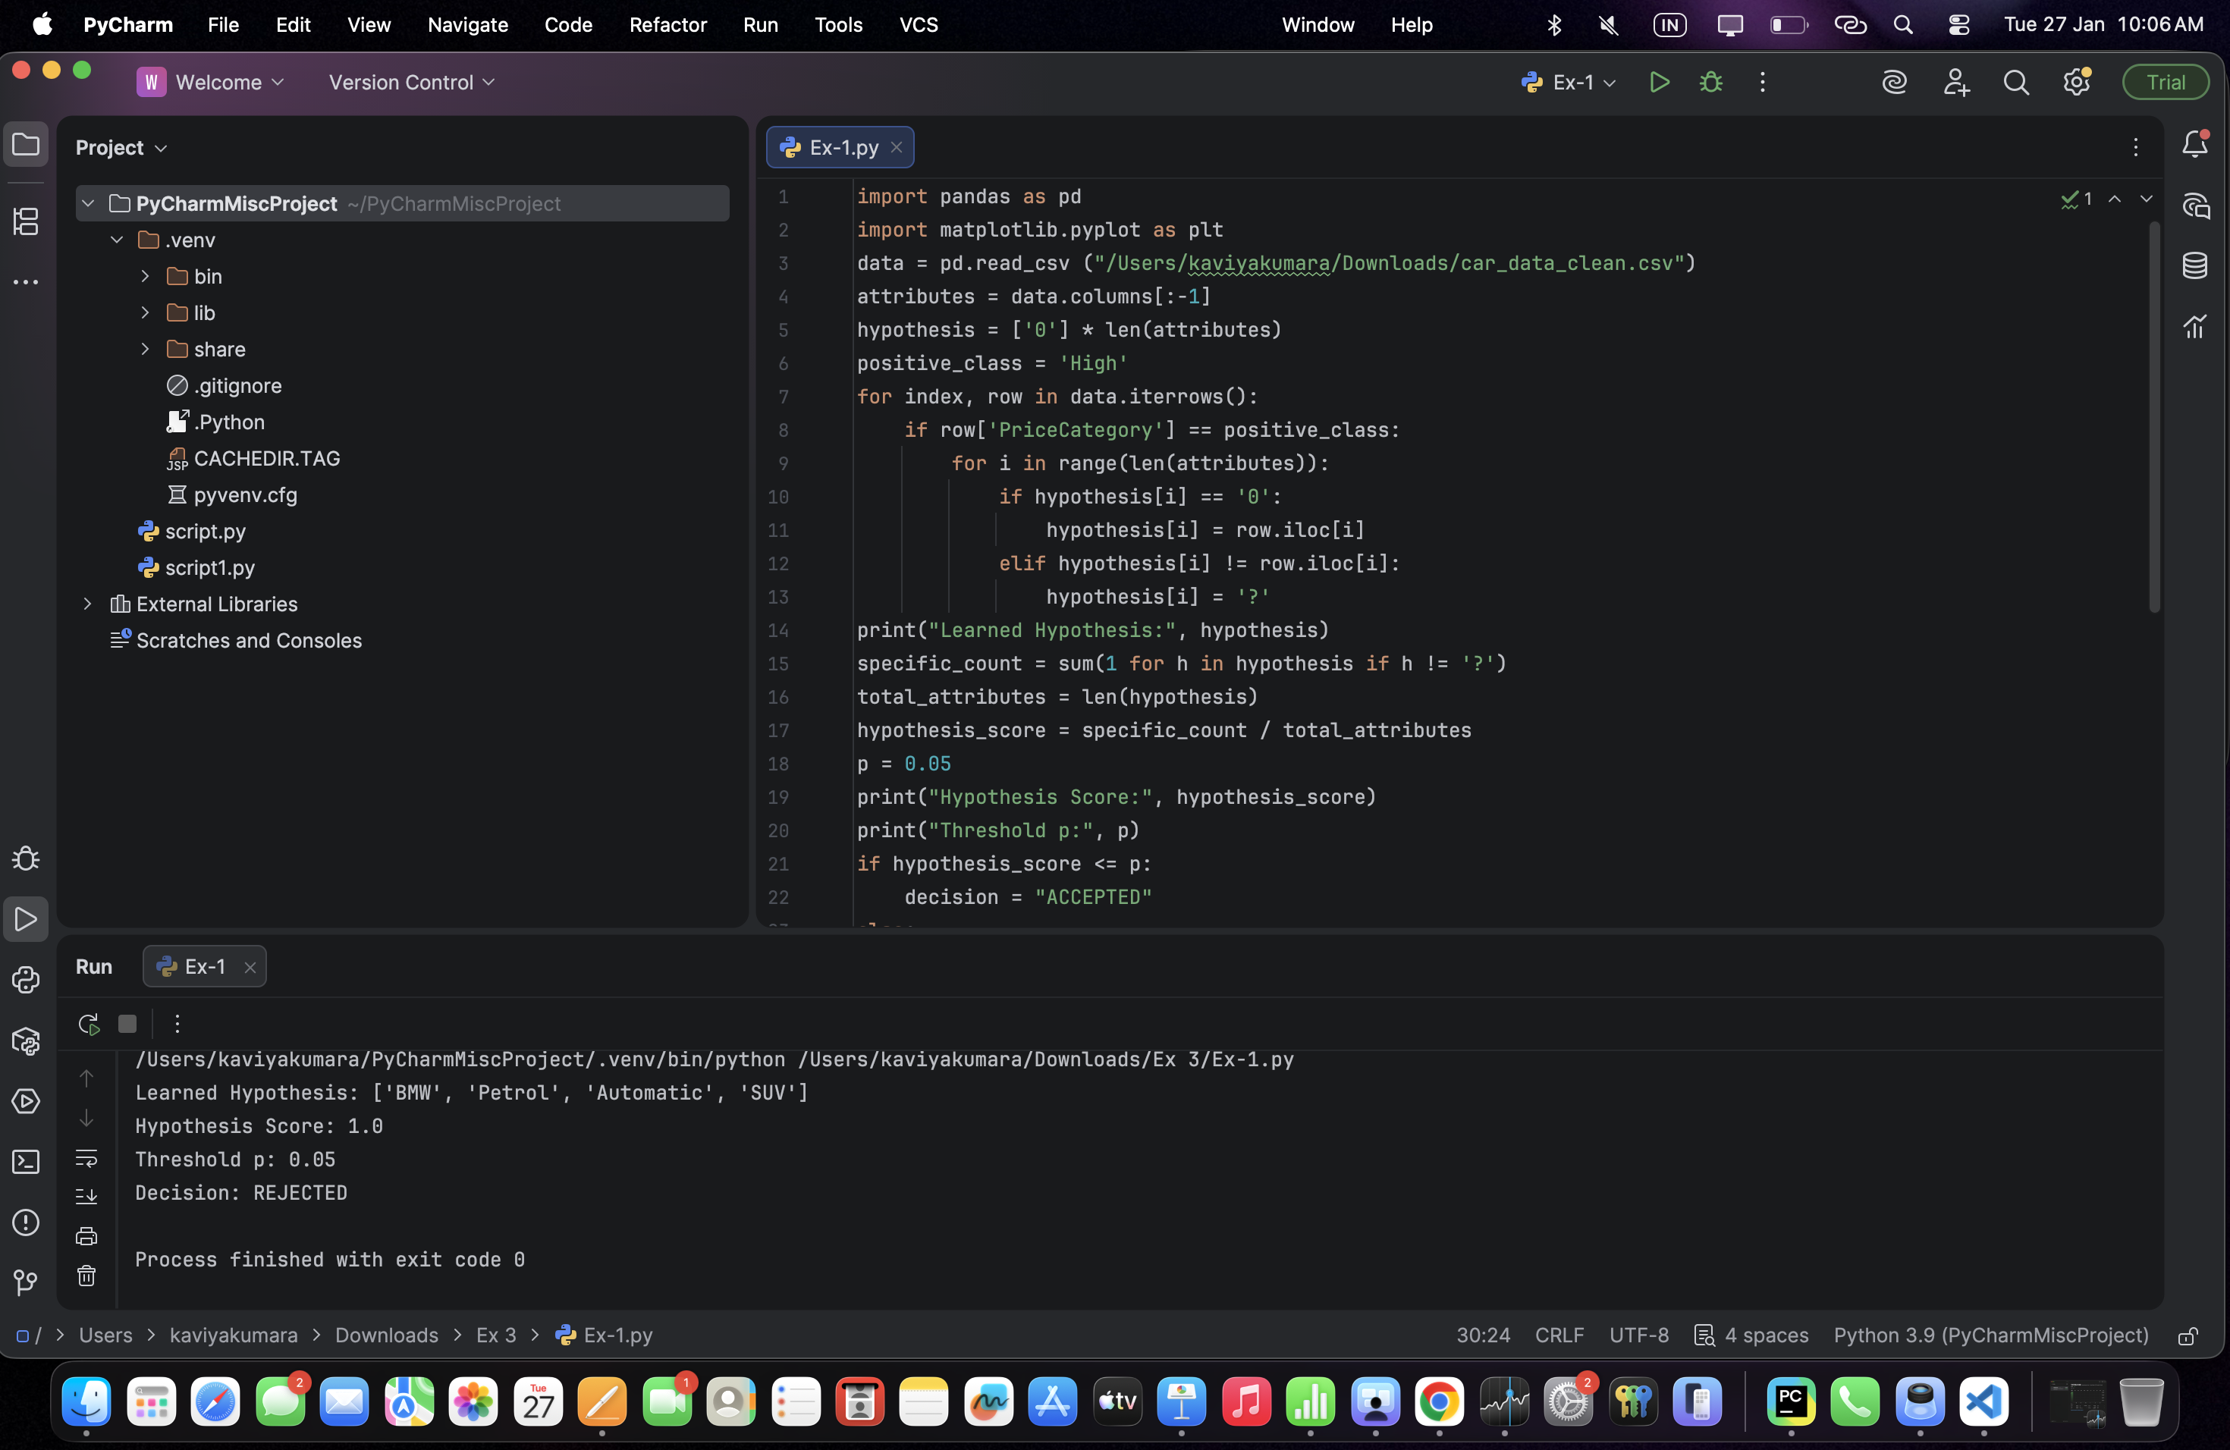
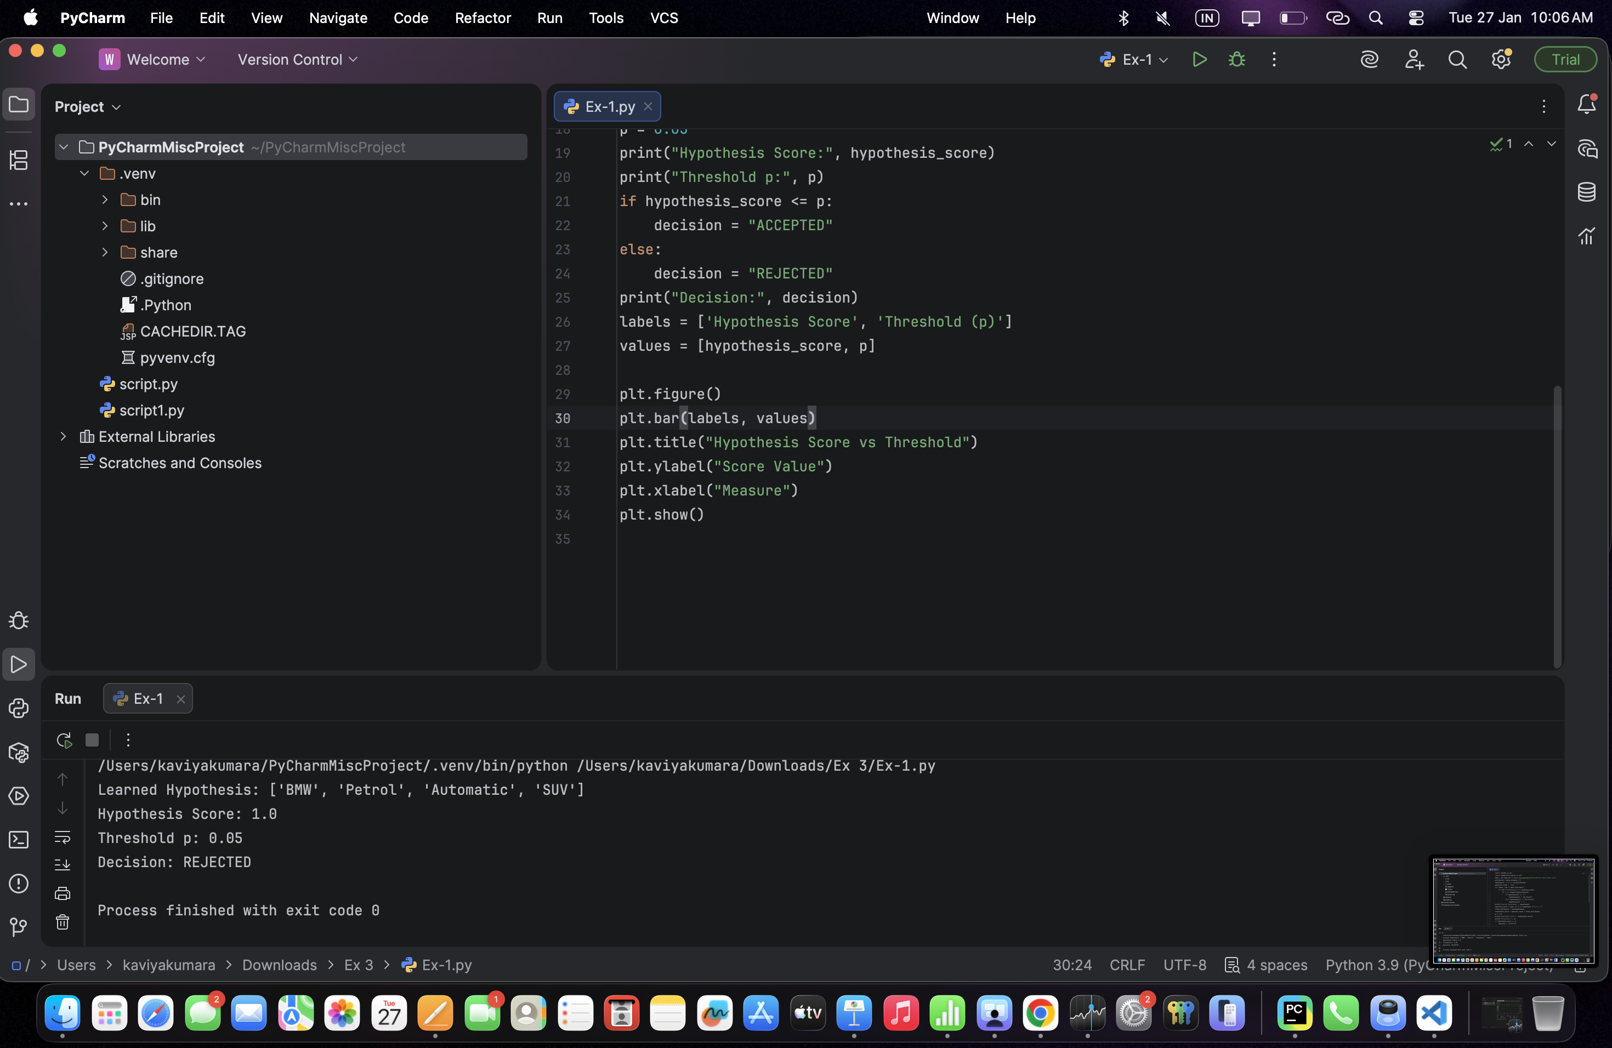
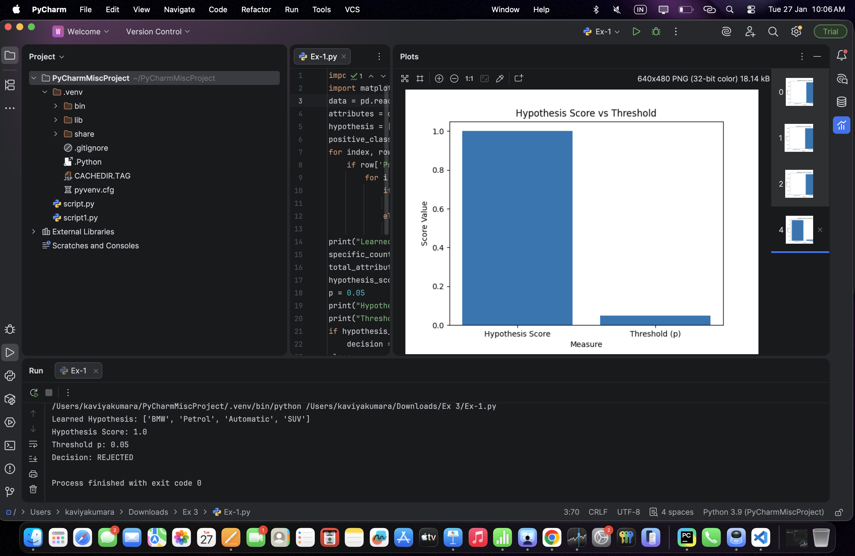
Output:

